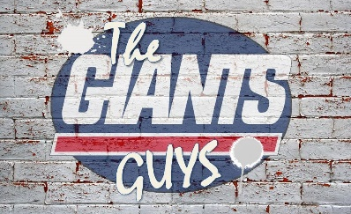
The Giants Guys 11/28/2020

- Craig Santucci – host.
- Eli & Spiro
Craig:
Welcome to another episode of The Giants Guys. I have Eli and Spiro in the lab tonight and I gave Michael Stewart and Mikey Fresh the Night off. So we can chop it up with a very special guest from ESPN, the QB guru, welcome in DAN ORLOVSKY.
We greatly appreciate the time. It’s been a rough 8 or 9 years for the Giants fan base. And the biggest question we get is here on the show is…Is Daniel Jones the franchise QB. We’ve all seen major strides in his game, however, he’s working limited resources. Injuries to 3 quarters of the Oline and his starting Running Back and all three receivers. You study the film and see what he has to work with. What do you see in Jones over all game?
[ELI]
Question. Potential Garrett question?

[Spiro]
In regard to Jones, or say a Darnold or Wentz last year, how hard is it to assess a QB that has no weapons around him and a bad line. Going back to your tweet from last week, you said a Good OL brings out the best in everyone. A Bad OL brings out the worst.
[Craig]

I’ve heard you talk about QB’s playing fast in the pocket. Is that something that’s just in you or is playing fast something that taught? How would you describe Jones in the pocket.

[Eli]
Question: Possible Barkley or Toney Question.

[Spiro]
How much of an OC’s job is to develop a QB?

[Craig]
Monday Night vs the Chiefs. What should be expected. They are banged up. Thru 7 games Mahomes has 11 turnovers. From 2018-2020 the 1st 7 games…he only had 7 turnovers combined. Can the Giants make this interesting?

Anyone can take this - Bonus Question:
To some degree you now watched 7 weeks of film on the Giants. They still can’t score, they are terrible in the redzone. Is this Garrett being conservative? Rudolph doesn’t need a ton of speed to out jump someone. Running the ball up the guts seems like a waste for a team ranked 25 in rush offense and 26th yards per carry.

